CONFIDENTIAL 345/1111


The information provided will be used for appointment to the University and upon appointment, for other appropriate purposes within the University. It might also be disclosed to internal departments/agencies authorised to process the information for appointment, e.g. for departmental/faculty review, health assessments, announcement of new appointments. Under the Personal Data (Privacy) Ordinance, applicants have rights to request access to and/or correction of their personal data held by the University. Requests should be made to the Assistant Registrar (Appointments), Human Resource Section, Registry, The University of Hong Kong (e-mail: apptunit@hku.hk). The University is an equal opportunity employer and adopts a policy of equal employment opportunities for persons with a disability.

For Office Use

Date received

Acknowledged

No.

APPLICATION FORM

for Executive, Clerical, Secretarial,
Technical and Research/Teaching Support Staff Grades

Please read the following notes before completing this form.

- Complete this form in BLOCK LETTERS. You may, if you wish, attach a full curriculum vitae, but please complete this form nonetheless, even where this duplicates the information provided, as it helps the selection committee to have basic data presented in a standard format. Applicants are advised to provide all the information requested in the form, where applicable, failing which the University may not be able to process and consider your applications.
- Please submit one application form for each post.
- Please send the completed form by e-mail (e-mail address as stated in the advertisement) by the closing date given in the advertisement.
- How did you learn this vacancy?
- If you have any close friends and/or relatives working in this University, please give their names in full and indicate their relationship with you. “Close relatives” include (a) spouse, (b) parents/parents-in-law, (c) brothers/sisters and brothers/sisters-in-law, and (d) children and their spouse.

Post applied for: Full-time Research Assistant Ref. no.: 201600974
Department: Centre for Enhancement of Teaching and Learning
Surname: Lu Given name(s) (in full): Xueyan
Title: Dr. / Mr. / Mrs. / Miss / Ms. * Name in Chinese: 陆雪砚
Date of birth: 1994/01／11 Nationality: China H.K.I.D. Card no.: M484802(6)
Address for correspondence: No. 9-11 TOPWORTH COURT THIRD STREET SAI YING PUN HK

Contact no.: 66761017 Office telephone no.:
Fax no.: E-mail address: cathlinabombom@gmail.com
Present salary: Expected salary: 16000 Availability: immediately
Give details of one person who is able and willing to comment on your suitability for the post in question; preferably this person should have knowledge of your recent academic or employment experience.
Name: HE Peichang
Position: Senior Research Assistant Company / University: The University of Hong Kong
Relationship with you: Project supervisor E-mail address: hepc1@hku.hk
Address: Hui Qi Chow Science Building
Should your application for this post not be successful, would you wish the University to retain your application for a maximum period of 6 months for consideration of any other suitable vacancy? Yes / No (please delete as appropriate)

I declare that the information I have given in this application is correct and complete to the best of my knowledge and belief.

Date 11/08/2016 Signature 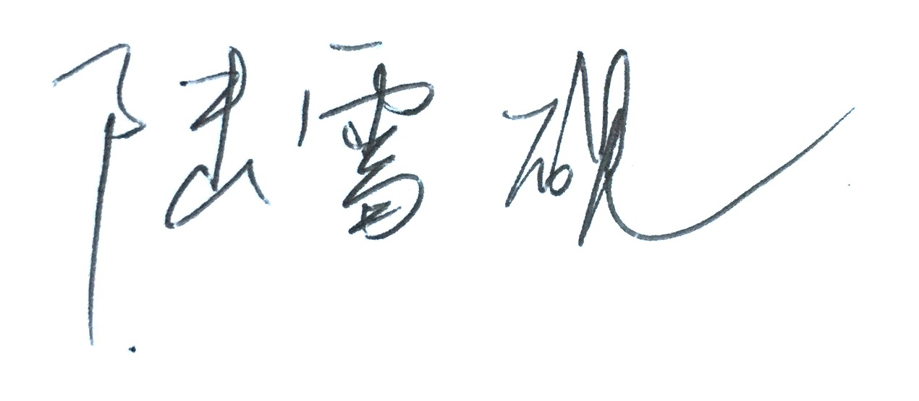

Name and Initials Lu Xueyan

SECONDARY EDUCATION
List the secondary schools you attended (if not in Hong Kong, please state the location)
Dates (month/year) |  | Name of School
From | To | Name of School
09/20o5 | 07/2008 | Hefei Yuying School
09/2008 | 07/2011 | Hefei No.1 High School
List the passes you obtained in public examinations (i.e. the Hong Kong Certificate of Education Examination [HKCEE], the Hong Kong Advanced Level Examination [HKALE] or equivalent)
Year | Exam. | Subject | Grade | Year | Exam. | Subject | Grade
2011 | College Entrance Examination | Chinese  English  Mathematics  Comprehensive courses of arts | 102  133  119  205
POST-SECONDARY EDUCATION
Provide details of any post-secondary education (e.g. University or Polytechnic), including dates of attendance, name of institution, subjects studied and qualification obtained (with grades or classification if any)
Dates of attendance  (month/year) |  | Name of Institution | Qualifications obtained and subjects studied  (with grades or classification if any) | Date of award (mm/yy)
From | To | Name of Institution |  | Date of award (mm/yy)
O9/2011 | 07/2015 | Anhui Normal University | Bachelor of Arts | 01/07/2015
09/2015 | 08/2016 | The University of Hong Kong | MATESOL | To be obtained
WORK EXPERIENCE (in descending chronological order):
Dates (date/month/year) |  | Name of Employment  Institution | Position Held  (if part-time, state PT) | Outline of Duties
From | To | Name of Employment  Institution | Position Held  (if part-time, state PT) | Outline of Duties
20/07/2014 | 20/08/2014 | Feixi Pengcheng Peixun School | English teacher | Knowledge review;  Preparation for College Entrance Examination.
15/01/204 | 15/02/2014 | Anhui Golden Garden Wood Villa Manufacturing Co., Ltd. | Clerk | Welcoming foreign customers;  Offering interpretation for company events;  Translating important foreign documents.
SKILLS
Computer skills: | MS Office; SPSS
Typing speed: | Fast | Shorthand speed: | Fast
Other skills | Pronunciation imitation; public speech; musical instruments(Gu zheng and Cucurbit flute)

